**

**Contents**

1. Connection Form: 1

2. Enter Data Form: 4

3. Mixed Palletizing Form: 6

# Connection Form:

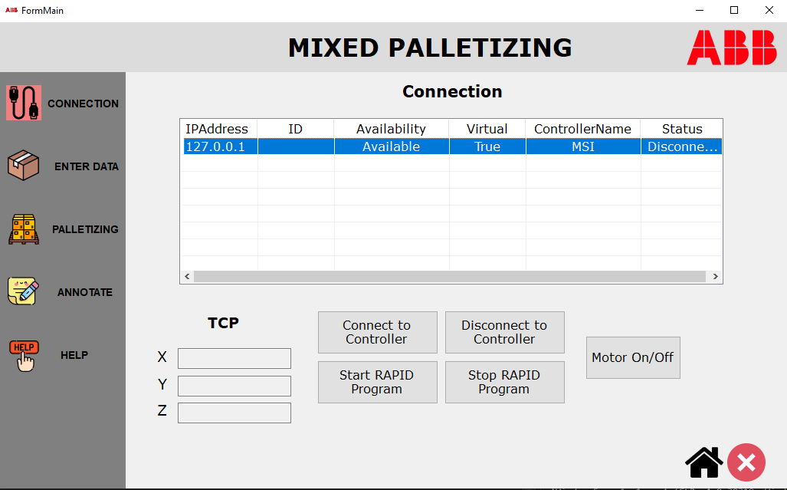

**In the Connection form we have:** 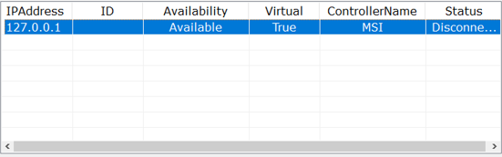

**This table contains information of robot’s controller:**

* IP Address – Address of Controller
* ID – You will see the ID when the controller is not virtual
* Availability – Whether you can connect to the controller or not
* Virtual – True if the controller is virtual and vice versa
* Controller nam- Name of the controller
* Status – Whether connected or not

*You must choose the controller that you want to connect before clicking* ***Connect to Controller button.***

**In TCP we have the coordinate of end – effector if the controller is connected :**

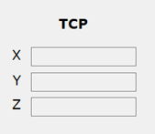

**We have 5 button:**

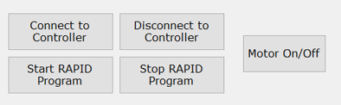

Connect to Controller button: Connect to the controller.

Disconnect to Controller button: Disconnect to the controller.

Start RAPID Program button: Run the Rapid and excecute the code..

Stop RAPID Program button: Stop the RAPID when you want to stop.

Motor On/Off button: Turn on/off the motor of real robot. *If you want robot operate with RAPID, turn on the motor before Starting RAPID.*

**When you connected successful the color will be changed to green:**



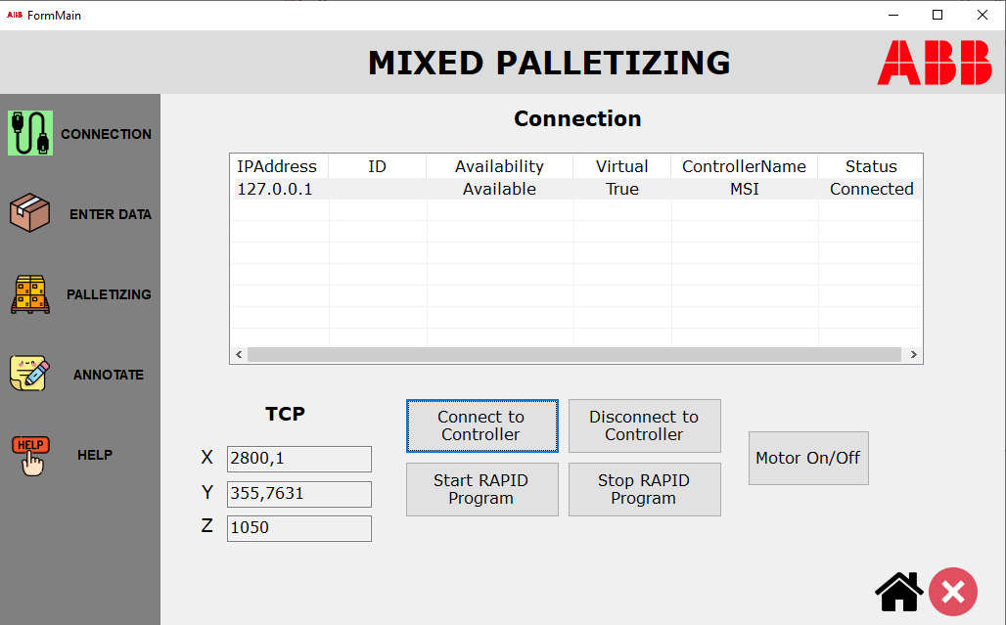

# Enter Data Form:

In the Enter data form we must fill out the input of he box:

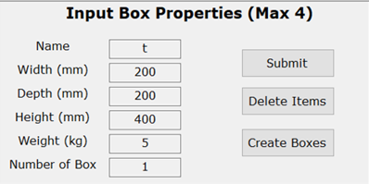

Box has 6 atributes: ***Name, Width, Height, Depth, Weight, Number of Box.***

After you fill all the information in this panel, clicking ***Submit button.***

All the parameters of the box will be displayed in the table below:

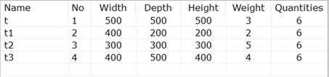

If you want to delete box you must choose that box in the table and click ***Delete Items***

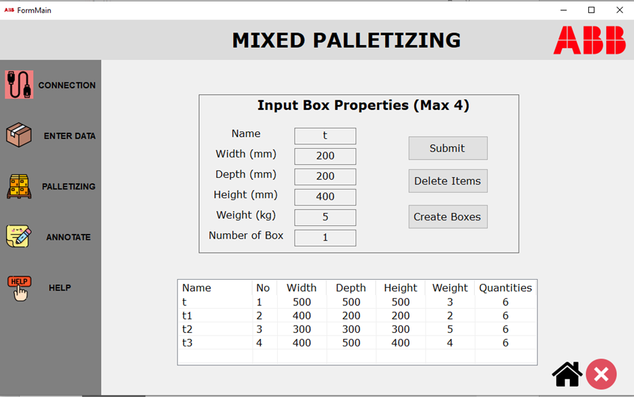

Then click Create Boxes button *(The station must be opened and connected before clicking Create Boxes button)*

Boxes in Robotstudio will be created. See the picture below:

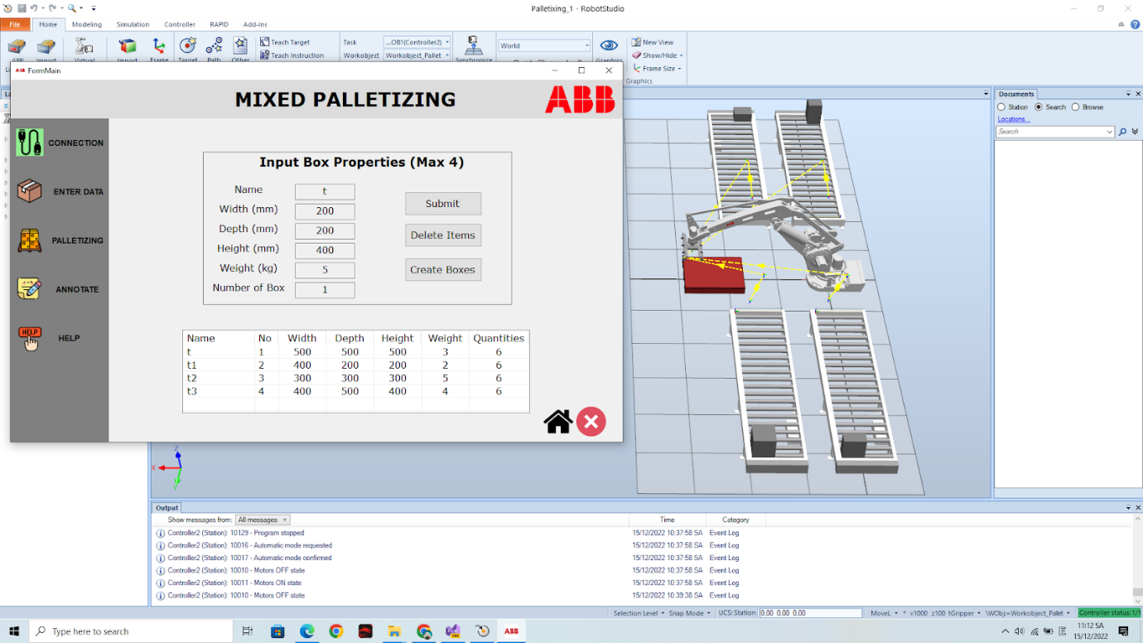

# Mixed Palletizing Form:

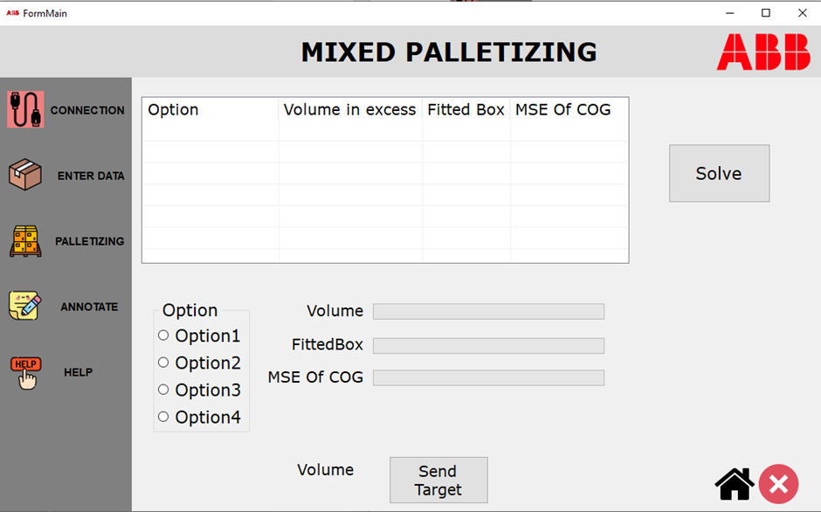

After Create box, clicking Solve. Wait for a while. The result will be dispalyed in the table.

There are 4 options in the table:

Each option has:

* Volume in excess: Uused Volume
* Fitted box: Total box that fit the pallet
* MSE Of COG: Error of the Center of Gravity

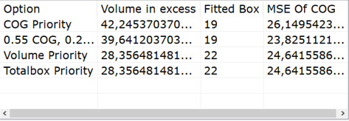

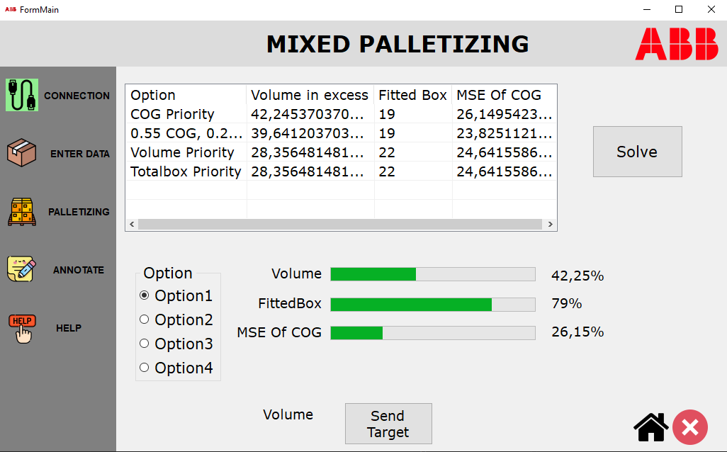

Then click Send Tarfet button: All target of the box that has been paacked on the pallet will be sent to robotstudio.

In RAPID code the tgPos will contains the target.

